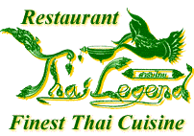

Beef Dishes

40. NUEA PHAD NAMMUN HOY…………………………………………………………..£9.25
Strips of steak sautéed with oyster sauce, onion, pepper and spring onions.

41. NUEA PHAD GAPRAO…………………………………………………………………£9.95
Strips of steak stir fried with chilli, garlic and fresh Thai basil.

42. NUEA OB LHAO DANG ………………………………………………………………£10.95
Fillet steak pieces stir fried with red wine sauce

