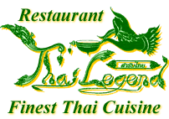

Thai Legend Restaurant
Special Set Lunch

Select One Starter
X X X X X X X X X

Select One Main Course
+
Rice
X X X X X X X X X

Tea / Coffee

£13.95 per person

5. GAI SATAE
Strips of chicken marinated in Thai spices, put on sticks and grilled over charcoal, served with peanut sauce and toast.

6. GAI HOR BAI TEOY
Cubes of chicken marinated in Thai spices and herbs, wrapped in pandon leaves and deep fried, served with sweet and sour chilli sauce

7. POR PIA TOD
Spring rolls filled with mixture of meat, glass noodles and fresh herbs, served with sweet and sour chilli sauce.

8. NUEA SATAE
Strips of beef marinated in Thai spices, put on sticks and grilled over charcoal, served with peanut sauce and toast.

9. SEE KRONG MOO NAM-PUENG YANG
Pork spareribs marinated in honey and fresh herbs, grilled over charcoal.

9A. SESAME TOAST
Freshly prepared sesame toast serve with sweet and sour chilli sauce.

9B. MOO PING
Strips of pork marinated in Thai spices, put on sticks and grilled over charcoal.

Vegetarian Starters

12. PAK MUNG SAWIRAT
Fresh mixed vegetables in special batter, crispy fried and served peanut sauce.

13. POH PIA PAK
Mixed vegetables cooked with Thai spices, wrapped in spring rolls pastry served with sweet and sour chilli sauce.

14. TOD MUN KHAO PODE
Sweet corn mixed with red curry paste, deep fried and served with cucumber and sweet chilli sauce.

Soup

15. TOM YUM HED
Mushrooms in spicy hot and sour, flavoured with lemon grass, lime leaves, chilli and coriander.

16. TOM KHA GAI
Chicken and mushroom in aromatic coconut milk soup, flavoured with fresh Thai herbs and coriander.

17. TOM YUM GAI (CHICKEN TOM YUM SOUP)
Traditional Thai spicy hot and sour soup flavoured with lemon grass, lemon juice, lime leaves, chilli and coriander

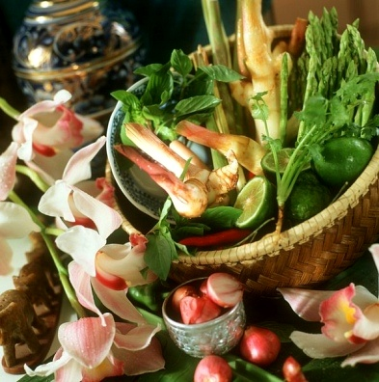

Thai Curry Dishes

30. GAENG KIEW WAN GAI (CHICKEN) OR NUEA (BEEF)
Chicken OR beef in green curry paste with coconut milk, Thai aubergines and herbs

31. GAENG PHED GAI
Chicken in red curry paste with coconut milk, Thai aubergines and bamboo shoots

33. PANAENG NUEA (BEEF) OR GAI (CHICKEN)
Beef OR chicken in dry aromatic curry with coconut milk, lime leves and chilli

35. GAENG MASAMUN KAE (LAMB) OR GAI (CHICKEN)
Lamb OR chicken cooked with onions, potatoes, milk, Thai curry rich in spices but quite mild even sweet

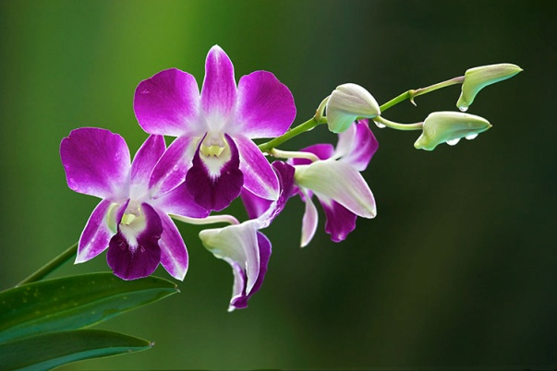
Beef Dishes

40. NUEA (BEEF) OR GAI (CHICKEN) PHAD NAMMUN HOY
Strips of steak OR chicken sautéed with oyster sauce, onion, pepper and spring onions.

41. NUEA PHAD GAPRAO
Strips of steak stir fried with chilli, garlic and fresh Thai basil.

42. NUEA OB LHAO DANG
Strips of steak stir fried with red wine sauce

Pork Dishes

50. MOO PHAD PRIEW WAN
Stir fried pork with pineapples, onions, pepper and cucumber in sweet and sour sauce.

51. MOO (PORK) OR NUEA (BEEF) PHAD PRIK SOD
Marinated pork OR beef stir fried with sliced chilli, garlic, onion and spring onions.

52. MOO TOD GRATIUM PRIKTHAI
Pork marinates with Soya sauce and Thai spices, stir fried with garlic, pepper and chopped coriander.

53. MOO PHAD GAPRAO
Stir fried pork with chilli, garlic and fresh Thai basil.

54. MOO PHAD PRIK
Stir fried pork with chilli paste, green bean and Thai fresh herbs.

Chicken Dishes

60. GAI OB SAPPAROD
Marinated chicken stir fried with pineapple pieces.

61. GAI PHAD KHING
Stir fried chicken with ginger, garlic, spring onions and fungus.

62. GAI PHAD PRIK GAPRAO
Chicken stir fried with Thai basil, garlic, chilli and fresh Thai herbs.

63. GAI PHAD MED MAMUANG
Sautéed chicken with cashew nuts, onion, mixed peppers with oyster sauce

64. GAI OB LAO DEANG
Stir fried chicken in red wine sauce

65. GAI TA-KHRAI
Stir fried marinated chicken with garlic, shallot, lime leave and lemongrass.

80. GAI YANG
Spring chicken marinated in garlic, fresh chilli, coriander and fresh Thai herbs, barbecued over charcoal.

81. GAI OB GRATIUM
Grilled marinated breast of chicken, slice and topped with garlic, black pepper, lemon grass and fresh coriander sauce.
Vegetarian Main Course

90. GAENG PAK RUAM
Fresh vegetables and dried bean cured cooked in red curry sauce with coconut milk and fresh herbs.

91. PAK PHAD PRIEW WAN
Mixed vegetables stir fired with cashew nuts in sweet and sour sauce.

92. PHAD PAK JOY
Glass noodles, mushrooms, bean curd stir fried with fresh vegetables.

93. PAK PHAD PRIK
Stir fried mixed vegetables with garlic and chilli

94. TAO HOO PHAD GAPRAO
Deep fried bean curd topped with mixed green vegetable, chilli and garlic.

101. PHAD PAK (NAMMON HOY)
Stir fried seasonal vegetables with or without oyster sauce.

113. PHAK KAET KHAAO PHAD NAMMON HOY
Stir fried Chinese leafs in oyster sauce.

114. TAO HOO NAM-DAENG
Cubed bean curd topped with mushroom, peas, carrots.

Chinese Dishes

111. BEEF OR CHICKEN IN BLACK BEAN SAUCE

112. SWEET AND SOUR CHICKEN

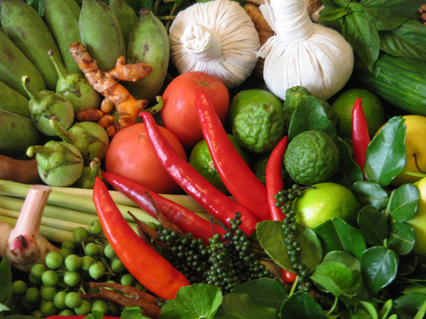
Rice
(*Please note the special set lunch come with one choice of rice)

96. PLAIN NOODLES
Plain noodles stir fried with dark soy sauce

102. KHAO PHAD GAI
Fried rice with chicken and herbs

103. KHAO PHAD KHAI
Thai fried rice with egg and fresh herbs.

104. KHAO PHAD GRATIUM
Thai fried rice with garlic

105. KHAO SUAY
Thai steamed jasmine rice

106. KHAO NIEW
Thai sticky rice.

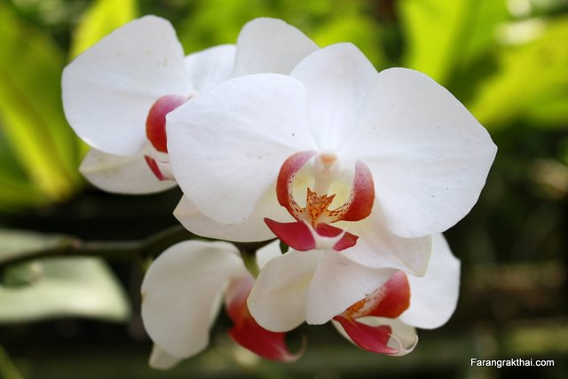

Special English Dishes

FISH & CHIPS £8.95
Deep fried cod in special batter, served with chips and peas.

CHICKEN & CHIPS £7.95
Thai Legend special prepared chicken deep fried and served with chips

(Please note that starters, tea and coffee are not include within the special English dishes)

